

**Team Name**: Tower Power

**Team Members:** Julia Guan, Jack McPherson, Jack Adam-De-Villiers & Andrew Burgess

**Game Name:** Mice Heist

Version 1.0

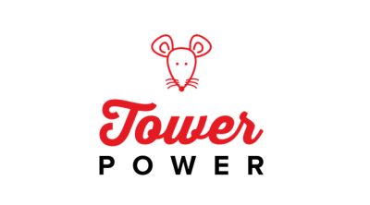

**Plot**

Richie's Righteous Restaurant is the best restaurant in town and everyone knows it. However due to the restaurants strict customer policy the mice and other sewer creatures aren’t allowed in. So they devise a plan to steal all of the restaurants ingredients.

Richie is very scared of these creatures so he enlists the help of some experts in the field to deal with this situation. The Coalition of Hamsters. They are mortal enemies of the Mice, legends say they have been warring factions for centuries.

Richie strikes a bargain with the Hamsters to assist him in this matter. They negotiate a payment of a specialised Hamster money, something the Mice would never consider stealing.

**Gameplay**

The hamsters construct towers and other various weaponised structures to combat the mice and repel their hoards.

Towers can be purchased and upgraded up to two times using the games currency, Hamster Dollars.

**Target Audience**

The game’s simple mechanics and charming visuals aim towards a broad, family friendly appeal appropriate for all ages.

**Visuals**

The towers the hamsters make are repurposed mugs while the setting of the scene will be in Richie’s kitchen. The visuals will be in a 3D modelled cartoon style.

**Sound**

The sound of Mice Heist will be simple cartoon impact and placement sounds for better immersion and to provide a better experience and a more enjoyable one.

**Music**

The music that is being implemented into the game will be steady rhythmic Jazz, for a calming and relaxing experience. The game will feature a full soundtrack of five songs and a main menu song.

Music was sourced from https://www.bensound.com/

**Tower Types**

On release the game will feature five different towers each with different functions all essential for completing the game.

**The Powerful Carrot shooter**

The Powerful PeaShooter is the cheapest but a well rounded tower. It doesn’t have any special abilities.

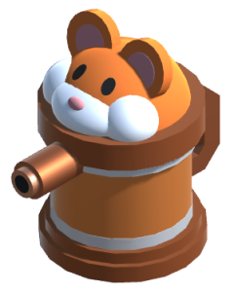

**The Mega Powerful PeaShooter**

The Mega PeaShooter is the ideal turret to deal quick damage and chip away at enemies health. It deals low damage but has the highest attack speed in the game.

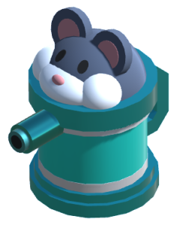

**The Plum Blaster**

The Plum Blaster operates like a cannon would, slow attack speed but with a large hit radius/area of effect.

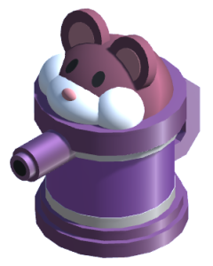

**The Red Chilli Launcher**

The Red Chilli Launcher is the most unique turret the game has to offer. It has modest range and damage, but what sets it apart is its unique ability to apply a damage over time effect of enemies.

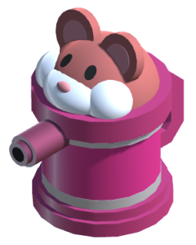

**The Gold King Tower**

The Gold King Tower is by far the best but most expensive tower in the game. It will have the highest damage best attack speed but immensely more expensive than the other towers but no increased range.

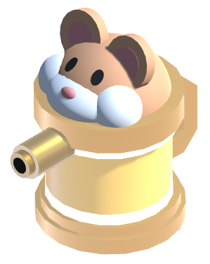

**Enemy types**

Mice Heist will feature three enemy types in the initial launch each displayed various changes with their appearance and stats.

**Crimson Missile**

The Crimson missile is the smallest enemy and has the lowest amount of health, but what it makes up for in lack of health is its speed and can dart past its allies while they are taking damage.



**Blue Menace**

The Blue Menace is the backbone of the mice organisation. They have moderate speed and health and are consistently taking damage so the Crimson Missile can sneak past defences



**Alpha Albino**

The Alpha Albino is the muscle for the mice. They are also the biggest mice in the game and have a massive health advantage to the rest of its companions. But due to its size its speed has been severely reduced



**Level layout**

The game will feature three different level all with different layouts, with the third level featuring a second spawner to increase the difficulty and intensity of the game.

**Level one**

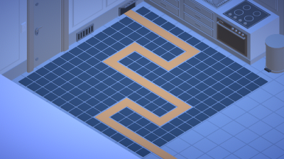

**Level two**

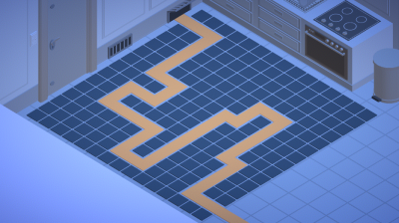

**Level three**

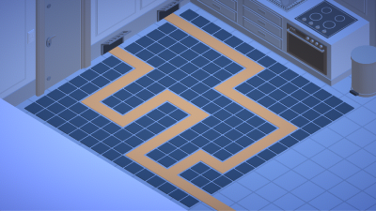

**Level four**

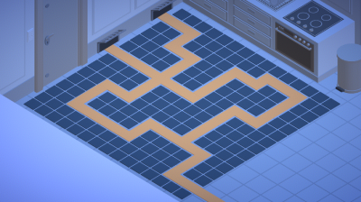

**Level five**

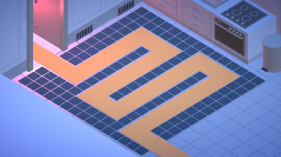

**Colour Palettes**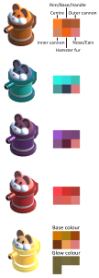

This is the colour palette used in the design process for the turrets

**Early Designs and concept art**

**Peach Health**

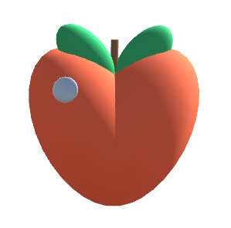

**Richie the Chef**

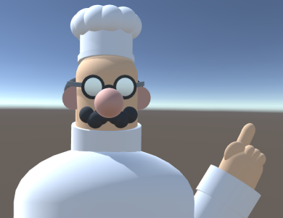

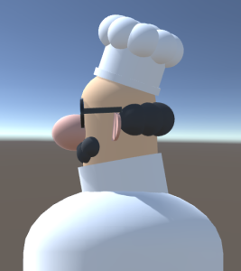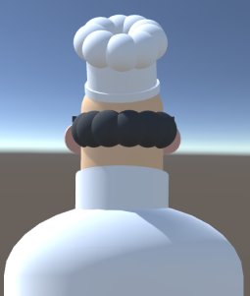

**Concept Logos**

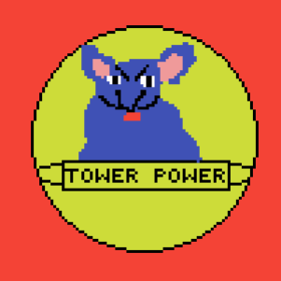

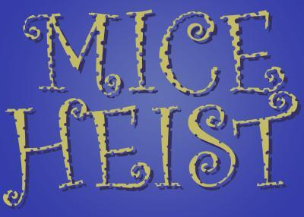

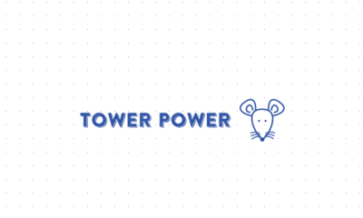

**Level Concept**

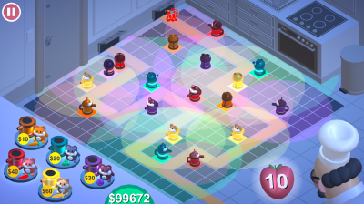**sq**

**Modelling the hamsters**

